PILOMAT ENERGY LONDON 8050

Semi automatic opening energy tower

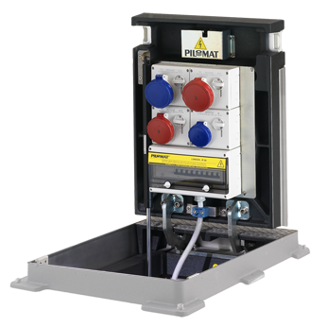

The purpose of developing PILOMAT LONDON B8050 is the different additional services like providing the electricity, telecommunications, compressed air and water. With PILOMAT ENERGY B3020 60 there is no need to lay temporary cables or pipes, therefore it looks more aesthetic appearence and guarantees greater safety to the users. The current design is the result of more than 15 years of continuous development.

Recommended applications
Pedestrian street – Parks – Mols – Marketplaces – Outside events - Concerts

General features
The PILOMAT ENERGY LONDON 8050 towers, with semi automatic operation, allow multiple installation methods, single-phase or three phase 16A or 32A, single-phase or three phase 16A in accordance with EN60301-1 EN60301-2 and related specifications. The cover plate placed at the top of the tower is in compliance with regulation UNI EN 124 with load class C250 or D400.
The PILOMAT ENERGY LONDON has a built-in a gas piston. Its structure is designed to mean no obstacle on the surface, due to the upper part can be closed after the cables are connected.

Technical specification

Moving part | Perlite iron
Dimensions of moving part | 710 x 480 x 450 mm
Height of moving part | 535 mm
Finish of moving part | Polyester powder painting – standard painting: anthracite grey
Length of cabel | Standard cabel: 3 meter
Protection classification of electrical components | IP 66 – IP67
Cover plate load class | D400
Fillable cover plate | yes

