**PILOMAT ENERGY LONDON 6040**

**Semi automatic opening energy tower**

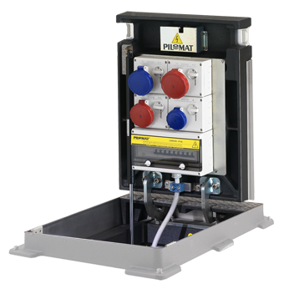

The purpose of developing PILOMAT LONDON B6040 is the different additional services like providing the electricity, telecommunications, compressed air and water. With PILOMAT ENERGY B3020 60 there is no need to lay temporary cables or pipes, therefore it looks more aesthetic appearence and guarantees greater safety to the users. The current design is the result of more than 15 years of continuous development.

**Recommended applications**

Pedestrian street – Parks – Mols – Marketplaces – Outside events - Concerts

**General features**

The PILOMAT ENERGY LONDON 6040 towers, with semi automatic operation, allow multiple installation methods, single-phase or three phase 16A or 32A, single-phase or three phase 16A in accordance with EN60301-1 EN60301-2 and related specifications. The cover plate placed at the top of the tower is in compliance with regulation UNI EN 124 with load class C250 or D400.

The PILOMAT ENERGY LONDON has a built-in a gas piston. Its structure is designed to mean no obstacle on the surface, due to the upper part can be closed after the cables are connected.

**Technical specification**

|  |  |  |
| --- | --- | --- |
| Moving part |  | Perlite iron |
| Dimensions of moving part |  | 710 x 480 x 450 mm |
| Height of moving part |  | 535 mm |
| Finish of moving part |  | Polyester powder painting – standard painting: anthracite grey |
| Length of cabel |  | Standard cabel: 3 meter |
| Protection classification of electrical components |  | IP 66 – IP67 |
| Cover plate load class |  | D400 |
| Fillable cover plate |  | yes |