PILOMAT ENERGY B4040 55

Semi automatic rising energy tower

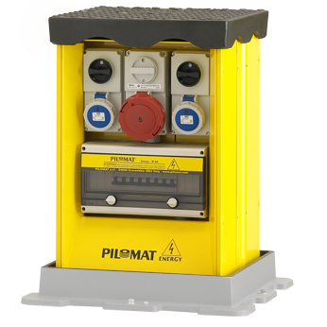

he purpose of developing PILOMAT ENERGY B4040 55 is the different additional services like providing the electricity, telecommunications, compressed air and water. With PILOMAT ENERGY B4040 55 there is no need to lay temporary cables or pipes, therefore it looks more aesthetic appearence and guarantees greater safety to the users. The current design is the result of more than 15 years of continuous development.

Recommended applications
Pedestrian street – Parks – Mols – Marketplaces – Outside events - Concerts

General features
The B4040 55 PILOMAT ENERGY towers, with semi automatic operation, allow multiple installation methods, single-phase and or three phase 16A, 32A, 63A, in accordance with EN60301-1 EN60301-2 and related specifications. The cover plate placed at the top of the tower is in compliance with regulation UNI EN 124 with load class C250 or D400.
The B4040 55 PILOMAT ENERGY equipment has semi automatic rising towers with a built-in gas actuator; their operation is similar to that of the semi automatic PILOMAT rising bollards.

Technical specification

Moving tower |  | FE 510 steel (iron) - AISI 304 stainless steel
Dimensions of moving tower |  | 400 x 400 mm
Height of moving tower |  | 550 mm
Finish of moving tower |  | Polyester powder painting – standard painting: yellow
Length of cabel |  | Standard cabel: 3 meter
Protection classification of electrical components |  | IP 66 – IP67
Cover plate load class |  | C250 – D400
Possibility of fillable cover plate |  | yes

