PILOMAT ENERGY B4030 60

Semi automatic rising energy tower

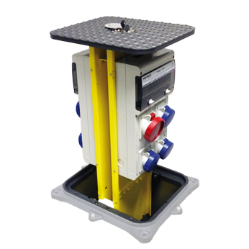

The purpose of developing PILOMAT ENERGY B4030 60 is the different additional services like providing the electricity, telecommunications, compressed air and water. With PILOMAT ENERGY B4030 60 there is no need to lay temporary cables or pipes, therefore it looks more aesthetic appearence and guarantees greater safety to the users. The current design is the result of more than 15 years of continuous development.

Recommended applications
Pedestrian street – Parks – Mols – Marketplaces – Outside events - Concerts

General features
The B4030 60 PILOMAT ENERGY towers, with semi automatic operation, allows multiple installation methods, single-phase and or three phase 16A, in accordance with EN60301-1 EN60301-2 and related specifications. The cover plate placed at the top of the tower is in compliance with regulation UNI EN 124 with load class C250.

Technical specification

Moving tower |  | FE 510 standard steel (iron)
Dimensions of moving tower |  | 400 x 300 mm
Height of moving tower |  | 600 mm
Finish of moving tower |  | Polyester powder painting – standard painting: yellow
Length of cabel |  | -
Protection classification of electrical components |  | IP 66
Cover plate load class |  | C250
Possibility of fillable cover plate |  | no

