Automatic hydraulic ANTI-TERROR bollard integrated pump
PILOMAT 275/P10 800A

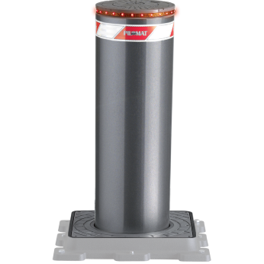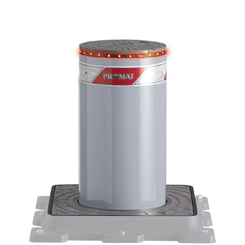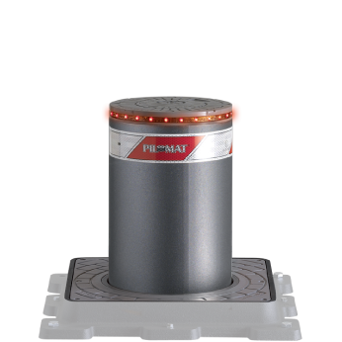

PILOMAT 275/P10 800A automatic rising bollard has one of the most popular products of PILOMAT range. The current design is the result of more than 15 years continuous development.

Recommended applications
Pedestrian streets – Pirvate Parking – Parking Companies – Private roads – industrial roads

General features
- Hydraulic movement: in case of intensive using is the most reliable technologie in all temperature range, in all wheather conditions.
- The integrated hydraulic pump into the bollard: This solution has many advantage, in the most cases the controller have to put away from the bollard but this solution reach the distance even the 80 meter.
- Certificated parts for reliable operation
- Optional Variability : unique color – integreated flashlight – buzzer – heating – UPS – control equipment

Technical specification

Bollard material |  | FE 370 steel (iron) – AISI 304 stainless steel
Nominal Diameter of Bollard |  | 275 mm
Nominal High of Bollard |  | 800 mm
Cylinder thickness (FE370) – stainless steel |  | 10 mm
Surface treatment (FE 370 steel) |  | polyester powder painting – factory base: antrahcite grey
Surface (stainless steel) |  | polyester powder painting – factory base: antrahcite grey or brushed, ribbed cylinder
Reflective athesive strip |  | 55 cm high
Rising speed |  | 15 cm/mp
Lowering speed |  | 25 cm/mp
Emergency manual lowering |  | To have options: automatic lowering
Control cabel lenght |  | Included cabel 10 meter (max. 80 meter)
Hydraulic pump |  | Built-in the bollard
Security classification |  | IP67
Type of usage |  | Intensive usage – average lifetime: 2.000.000 operation – 2.000 operation/day
Impact resistance (without deformation) |  | 40.000 J (1.200 kg @ 29 km/h – 2.000 kg @ 23 km/h)
Breakout resistance |  | 400.000 J (1.200 kg @ 93 km/h – 2.000 kg @ 72 km/h)
Operating temperature |  | -40°C - + 70°C (with heating)
Nominal weight (with mechanics, without pit) |  | 150 kg
Nominal weight (pit and fixing equipment) |  | 66 kg

