Automatic hydraulic ANTI-TERROR bollard integrated pump
PILOMAT 275/K4 700A

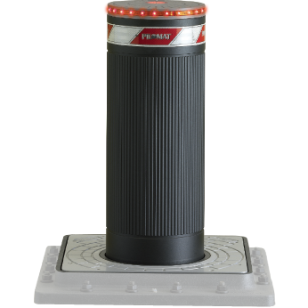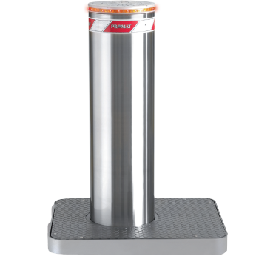

PILOMAT 275/K4 700A automatic rising bollard has been created against terror attack. The current design is the result of more than 15 years continuous development.
PILOMAT ANTI-TERROR bollards are qualified with the ASTM/PAS 68 regulation.

Recommended applications
Office vehicle drives – Industrial vehicle drives – Research centers – Embassies – Police stations – Military objects – Ministries – Strategic objects

General features
- Hydraulic movement: in case of intensive using is the most reliable technology in all temperature range, in all wheather conditions.
- The integrated hydraulic pump into the bollard: This solution has many advantage, in most cases the controller has to be installed apart from the bollard, with this solution the distance can be even the 80 meter.
- Certificated parts for reliable operation
- Optional Variability : unique color – integreated flashlight – buzzer – heating – UPS – control equipment

Technical specification

Bollard material |  | FE 510 steel (iron)
Nominal diameter of Bollard |  | 275 mm
Nominal height of Bollard |  | 700 mm
Cylinder thickness |  | 10 mm
Surface treatment (FE 510 steel) |  | polyester powder painting – factory base: antrahcite grey
Surface (in case of other material) |  | ribbed robe – 316 AISI stainless brushed steel
Reflective adhesive strip |  | 55 cm high
Rising speed |  | 10 cm/mp
Lowering speed |  | 22 cm/mp
Emergency manual lowering |  | To have options: automatic lowering
Control cabel lenght |  | Included cabel 10 meter (max. 80 meter)
Hydraulic pump |  | Built-in the bollard
Security classification |  | IP67
Type of usage |  | Intensive usage – average lifetime: 2.000.000 operation – 2.000 operation/day
Impact resistance (without deformation) |  | 150.000 J (2.000 kg @ 44 km/h – 6.800 kg @ 24 km/h)
Breakout resistance |  | 700.000 J (2.000 kg @ 95 km/h – 6.800 kg @ 52 km/h)
Operating temperature |  | -40°C - + 70°C (with heating)
Nominal weight (with mechanics, without pit) |  | 180 kg
Nominal weight (pit and fixing equipment) |  | 150 kg

