Fix ANTI-TERROR oszlop

PILOMAT 275/K4FB 900F

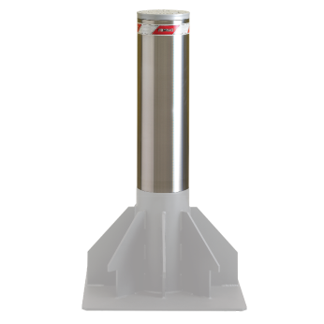

A PILOMAT 275/K4 900F fixed bollards have been created on the manufacturing process to be the same appearance and technical features as the moving PILOMAT in order to combine the two version. The current design is the result of more than 15 years of continuous development
.

Ajánlott alkalmazási területek
Pedestrian street – Private parking – Parking companies

General features
- The fixed anti-terror PILOMAT bollard is used that is to isolate and prevent impact with the vehicle the following areas: Research centers, eEmbassies, Police stations, Military objects, Ministries.

- K Series: The bollards that look the same as the moving bollards, with these can provide cost-effective the appearance of unified entrances. If necessary it is possible to remove the bollard quickly and easily.
- Optional Variability: unique color – integreated flashlight – FE370 or AISI 304 stainless steel bollard.

Műszaki specifikáció

Bollard material |  | FE 510 steel (iron)
Nominal Diameter of Bollard |  | 275 mm
Nominal High of Bollard |  | 900 mm
Cylinder thickness (FE 510 steel) |  | 10 mm
Surface treatement (FE 510 steel) |  | Anticorrosion treatment + grey anthracite standard painting
Other Surface treatement |  | Ribbed surface – AISI 316 brushed, stainless steel, cover (1,5 mm)
Reflective athesive strip |  | To have - 55 cm high
Impact resistance (without deformation) |  | 150.000 J (2.000 kg @ 44 km/h – 6.800 kg @ 24 km/h)
Breakout resistance |  | 700.000 J (2.000 kg @ 95 km/h – 6.800 kg @ 52 km/h)

