Fixed ANTI-TERROR bollard

PILOMAT 127/PL 800F

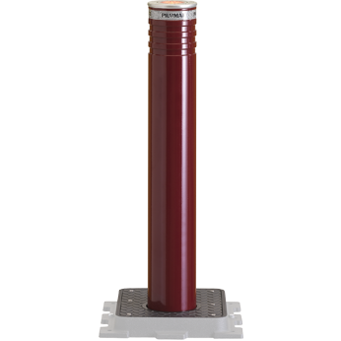

A PILOMAT 127/PL 800F fixed bollards have been created on the manufacturing process to be the same appearance and technical features as the moving PILOMAT in order to combine the two version. The current design is the result of more than 15 years of continuous development

Recommended applications
Pedestrian street – Private parking – Parking companies

General features
- The fixed anti-terror PILOMAT bollard is used that is to isolate and prevent impact with the vehicle the following areas: Research centers, eEmbassies, Police stations, Military objects, Ministries.

- PL Series: The bollards that look the same as the moving bollards, with these can provide cost-effective the appearance of unified entrances. If necessary it is possible to remove the bollard quickly and easily.

- Optional Variability: unique color – integreated flashlight – FE370 or AISI 304 stainless steel bollard.

Technical specification

Bollard material |  | FE 370 steel (iron) - AISI 304 / 316 stainless steel
Nominal Diameter of Bollard |  | 127 mm
Nominal High of Bollard |  | 800 mm
Cylinder thickness (FE 370 steel) / (stainless steel) |  | 6 mm/ 6 mm
Surface treatement (FE 370 steel) |  | Polyester powder painting – standard painting: grey anthracite
Surface treatement (stainless steel) |  | Polyester powder painting – standard painting: grey anthracite - brushed
Reflective athesive strip |  | To have - 23 cm high
Impact resistance (without deformation) |  | 30.000 J (1.200 kg @ 25 km/h – 2.000 kg @ 20 km/h)
Breakout resistance |  | 150.000 J (1.200 kg @ 57 km/h – 2.000 kg @ 44 km/h)

