Semi automatic rising bollard integrated pump into the controller
PILOMAT 127/PL 600SA

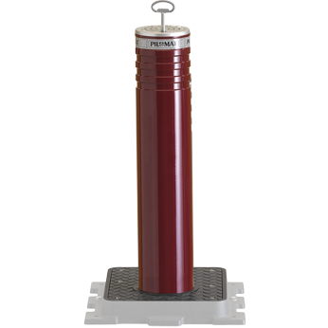

PILOMAT 127/PL 600SA semi automatic bollard uses gas piston and have been created on the manufacturing process to be the same appearance and technical features as the moving PILOMAT in order to combine the two version. The current design is the result of more than 15 years of continuous development

Recommended applications
Pedestrian street – Private parking – Parking companies – Private roads – industrail roads

General Features
- The aim of development the semi automatic rising bollard of PILOMAT, release in the trafic temporarly to the pedestrian streets and private areas in order to pass over and stay there. The semi automatic PILOMAT bollard recommended for limited daily use. (in other case suggest to use the automatic rising PILOMAT bollard).

Operation
- Raising: a mechanical key opens the lock and thanks to the gas piston the column automatically rises; when it reaches the top position, the system is automatically locked to prevent unauthorized usege.
- Sinking: the lock have to open with the mechanic key, and push the bollard toward the ground; when it sank completely, the system will be closed in order to stop the rising of the bollard.
- Opcional options:
  - FE370 or AISI 304 stainless steel bollard
  - Unique color
  - Light signal
  - Unique mechanic key

Technical specification

Bollard material |  | FE 370 steel (iron) – AISI 304/316 stainless steel
Nominal Diameter of Bollard |  | 127 mm
Nominal High of Bollard |  | 600 mm
Cylinder thickness (FE 370 steel) / (stainless steel) |  | 6 mm / 6 mm
Surface treatement (FE 370 steel) |  | Polyester powder painting – standard painting: grey anthracite
Surface treatement (stainless steel) |  | Polyester powder painting – standard painting: grey anthracite - brushed
Reflective athesive strip |  | To have - 23 cm high
Impact resistance (without deformation) |  | 30.000 J (1.200 kg @ 25 km/h – 2.000 kg @ 20 km/h)
Breakout resistance |  | 150.000 J (1.200 kg @ 57 km/h – 2.000 kg @ 44 km/h)

